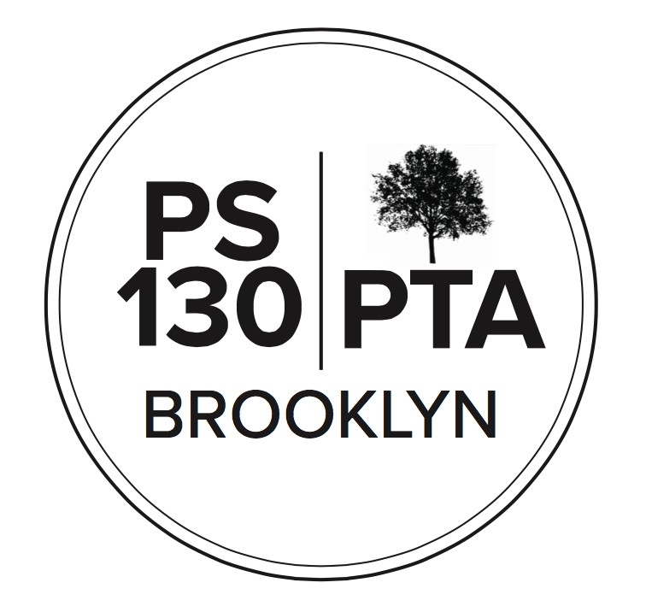
PS 130 PTA Meeting Agenda
November 17, 2022, 6:00 pm
Call to Order
Reading of Minutes
Principal’s Report (10 min) (Stephanie Parsons)
Excited about the upcoming Coffee and Donuts event with parents and Admin. Biobus is coming back. Our webmaster is on medical leave, trying to get someone new trained, we will be working with the new person to update a lot of things. Admin is in conversation with different stakeholders – staff and UFT reps and other unions, equity team, SLT, about Family Fridays and class celebrations. We’re getting closer to having a way for these to happen that everyone is comfortable with. Hopeful that we’ll be able to have that soon.
A ”lunch survey” went out; we haven’t had to do that for a while but have to do it again this year. Now it’s called the Family Income Survey. We sent the link on Konstella, can send out again. Want as many families as possible to complete. The info is only used to determine Title 1 funding. The info doesn’t go anywhere else; it isn’t shared publicly. The due date is coming up. It will help the school if families fill out these forms. The more people who participate in the collection of info, the better. If we lose Title 1 funding, it will go away gradually, it won’t be abrupt.
Parent Coordinator Report (5 minutes) (Jackie Hardy)
We’re having Kindergarten virtual open house on 12/8. Will have monthly parent workshop—one coming up that’s an overview of students’ accounts (Myschools, etc.). A flyer for that will go home Monday. Next Thursday and Friday is no school.
Kristie Dantes: K and 1st graders were sent home info about Kids for College program, it’s a savings program where you can earn money that’s saved for them. Everyone is automatically enrolled. Deadline to opt out is 11/18.
Erin Langstaff: Middle school application deadline coming soon. Can help with translation. If anyone needs more info, can reach out to Erin or Jackie.
Finances (10 minutes) (Regan Vidiksis)
- Treasury report: Assets: $177K, Income $23,209. Fall Fest income close to $22,000. Expenses: $21,405. Yearbook: prepaid for hardcover and softcover: $9,334.
- Budget amendment: Aplos Financial Software cost went up to $1,800, more than double of what it has cost. Regan: will do research to see if we can find a better solution. Passed.
New Business
- Fundraising: (5 minutes) (Kara Murray)
  - Annual Appeal goal: $85,000. The PTA funds Arts Connection, Biobus, ICN chess enrichment, Visiting Artists, Professional Development. $350 per child is requested. Please check if your employer matches.
  - PTA Store- new merch coming soon! Ordered new merchandise with old tree design, new T-shirt design and new sweatshirt design. And socks. Will sell in December.
  - Fall Fest report (Liz Edmunds): Had a really successful event. Brought in $22,800. Spent about $6,000. Net around $16,000.
  - Foley Firs fundraiser
- Community Building (15 minutes) (Diana Rosenthal)
  - Thank you to everyone who attended Bangla and Spanish-speaking family nights! Shahana Hanif came to Bangla night, great speakers at Spanish night.
  - Holiday Gift Drive (Jen Uva) Benefits 120 kids every year. We buy kids coats, hats, and boots. And gift cards. Need help with purchasing items. Trying to raise $9,000, have $6,000 left over from last year.
  - Coffee and donuts with admin
■ Lower school, Monday November 21 after dropoff, 8:30 – 9:15
■ Upper school, Tuesday, November 29 after dropoff, 8:30 – 9:15
  - BioBus November 21 for third grade
  - Winter Bazaar – canceled.
  - Have an idea for an event you want to coordinate? Please get in touch!
- Committee Updates (3 minutes) (Matt Brown)
  - Fifth grade committee: Thanks to those who came to Joyce Szuflita’s talk. Donations made covered the cost of the event. Thanks to Kara and Jenny Shore for organizing the bake sale, it raised over $700. Some tours are left: 447 and 442 on Monday. 839 tomorrow. Tentative date for next fundraising event: Photography with Thomas, hopefully some time in January.
Adjournment
Important Reminders
- November 24-25, Thanksgiving Recess, schools closed
Upcoming Events
- November 21 - BioBus (third grade)
- November 21, 5:00 pm- Virtual SLT Meeting
- November 30, 7:30 pm - Virtual Afterschool Committee Meeting
- December 1, 6:00 pm - Virtual Equity and Inclusion Committee Meeting (new dates- first Thursday of every month)
- December 1, 7:00 pm - Virtual Parent Workshop on DOE NYC School Account (NYCSA)
- December 5, 7:30 pm - Virtual PTA Executive Board Meeting
- Next PTA meeting is on Dec. 15th
NEXT PTA MEETING - THURSDAY, December 15, 6:00 PM
Please “like” our PS 130 PTA Facebook page & follow us on Twitter + Instagram@ps130PTA Reach out: info@ps130pta.org

