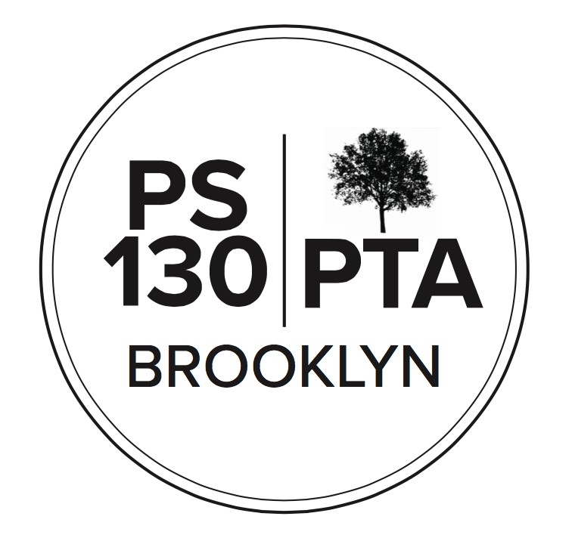
PS 130 PTA Meeting Agenda
September 22, 2022, 6pm
**Please note that this meeting will be recorded**
Call to Order
Reading of Minutes
Principal’s Report (10 min) - to continue after vote
- School Leadership Team (SLT) (two openings)
The SLT looks at the Comprehensive Education plan together; parents and teachers work together to find solutions to any problems; SLT members do a great service to the school
New Business - to continue after Finances
- Nominations & VOTE for elected positions: (20 minutes)
  - SLT (two openings)
Stacy Alicea and Grace Edmonds nominated for SLT, elected
  - Members at Large (eight openings)
Nominations: Rebecca Press, Laura Nemerson, Allison Bellevue, Liz Edmund, Lisa Yakuboff, Shaipe Dokovic, Ben Struck, Zachary Green, Mayra Aidas, Jonathan White
Elected: Rebecca Press, Laura Nemerson, Allison Bellevue, Liz Edmund, Ben Struck, Zachary Green, Mayra Aidas, Jonathan White

  - Executive Board Members (unfilled in Spring):
- Vice President(s) of Events (two openings)
Eli Reed nominated and elected
Principal’s Report (10 min) - continued
- Covid protocols: Covid protocols have changed. Now, first day of symptoms is Day Zero, next day is Day One. Can Return on Day Six. A lot of cases were reported at the start of school but in the last few days, no cases reported. There are more air purifiers in both buildings than last year. Teachers are keeping the windows open. Lunch has to be served inside; the food dept. isn’t packing up hot lunches this year for outside eating.
- Opportunities for family engagement in the classrooms: Not sure how Family Fridays will be phased back in. Teachers are creating opportunities for parents to sign up to come into class. Defintion of Family Fridays: pre-Covid, one Friday morning each month, family members could come to school and take part in a classroom event. The school was full of parents. A lot of teachers and staff afraid of Covid spread. Working hard to find ways families can come in the building.

Parent Coordinator Report (5 minutes)
University Settlement: There is a lot of interest in University Settlement, only a few available seats left. U.S. is working on staffing and then will do a lottery for the few spots left in mid October. Over 100 people on the wait list.
U.S. has a new program at PS 130 called Families Thriving, a resource for the school community that destigmatizes mental health, eases transition into school, provides counseling, does skill-building groups, and teaches parents tools.
Finances
- Treasury Report: Our assets are $183,105. In Fiscal Year since 7/1, our Income was $23,456. Expenses were $9,917.
New Business (con’t)
- 2022/2023 Budget presentation & VOTE
Our income proposed for 2022-2023 is $112,800
Changes: Library support went from $15k to $5k; the school has asked the PTA for support for Arts Connection; Garden Committee has asked that unused $1k from last year be added to this year’s budget

- Fundraising: (3 minutes)
  - PTA Store
  - Annual Appeal goal: $85,000
- Community Building (15 minutes)
  - Fall Fest - Save the Date for October 22! Update: we’ve had difficulty securing a permit to get 7th St. closed for 10/22, looking at either a scaled-down event or having it on 12/2.
  - BioBus: BioBus is back, 4th graders will go on it next week.
  - Konstella
- Committee Update (10 minutes)
  - Afterschool Committee: 18 pickup programs, 3 on-site. We’d like to hire an Afterschool Coordinator—there’s a teacher who’s been helping. Having someone in the building who’s a liaison would be extremely helpful. The committee currently has no budget line item for it.
  - Art Committee – Art Box: The Art Committee has two new co-leaders, Abby Koons and Judy Shatzy. Art Committee assists Ms. Kirsten, the art teacher, sets up the annual Cardboard Challenge, and provides supplies for curriculum-based art projects in Grades K-5. Alyson Campbell heads up Art Box, need more volunteers for Art Box.
  - Music Committee: looking for a new chair
  - Fifth Grade Committee: chairs are Matt Brown, Gretchen Nealon, and Deirdre Struck. Will be in touch soon with 5th Grade families. First order of business will be the Middle School forums. 5th Grade end-of-year activities will include picnic, dance, awards ceremony, graduation, maybe a Broadway show. There will be dues and fundraising.
  - Health Committee: supports health and wellness. Last year sponsored the Covid testing bus, tapping classes, yoga classes, and lice checks.
Adjournment
Important Reminders
- September 26 & 27 - Rosh Hashanah, schools closed
- October 5 - Yom Kippur, schools closed
- October 10 - Italian Heritage / Indigenous Peoples' Day, schools closed
Upcoming Events
- September 28 - BioBus (fourth grade)
- September 29, 5:00 pm- Virtual SLT Meeting
- October 3, 6:00 pm - Virtual Equity & Inclusion Meeting
- October 3, 7:30 pm - Virtual Exec Board Meeting
- October 17, 5:00 pm - Virtual SLT Meeting
- October 20, 6:00 pm - Virtual PTA Membership Meeting
- October 22 - PTA Fun Run
- October 22, 11-3:30pm - Fall Fest
NEXT PTA MEETING - THURSDAY, October 20, 6:00 PM
Please “like” our “PS 130 PTA” Facebook page follow us on Twitter + Instagram@ps130PTA

