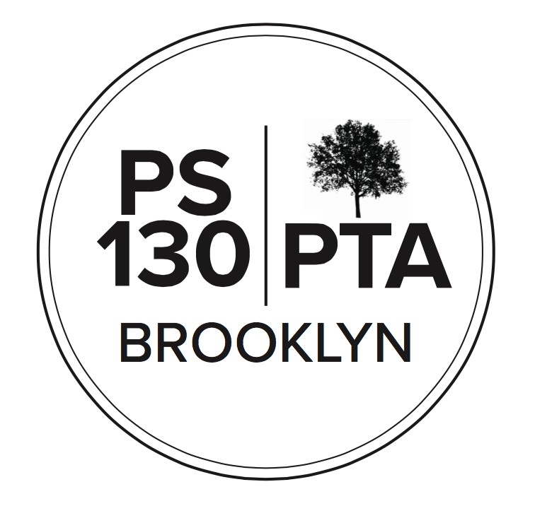
PS 130 PTA Meeting Agenda
October 20, 2022, 6:00 pm (via Zoom)
Title I Meeting (15 min)
Call to Order
VOTE for Title 1 parent and Title 1 alternate
Title 1 is a school-wide plan, so all students are Title 1. We have a Title 1 parent advisory committee and need to elect a new chairperson this year. The chairperson comes to SLT meetings and plays an advistory role. A certain part of Title 1 funding is decided by SLT in consultation with Title 1 chairperson. This person tries to stay on top of what families are interested in and need. So far no one has expressed interest to Jackie. Is there anyone interested? If no one expresses interest in the role, Admin will reach out to others to try to find someone.
Close of Title I Meeting
General Body Meeting Call to Order
Reading of Minutes – waive reading of minutes
Principal’s Report (5 min) – Bangla-speaking family night on Oct. 25, Spanish-speaking family night on Oct. 27. Visitors from Shahana Hanif’s office and ICN Chess will attend to hear what people in these communities are thinking about. Parent Teacher conferences are on 11/3. Dismissal at 11:45 that day. DEI meeting on Nov. 7th. Election Day is Nov. 8th, no school. Veterans Day Nov. 11th , no school.
Maker Space – a team of people working to get that room back in order so students can get back to STEAM/STEM activities.
Parent Coordinator Report (5 min) Next Friday there will be Class Parent training. Jackie will send email to Class Parents tomorrow. Class Parents have access and can send announcements to parents on Konstella.
Picture Day is Nov. 15th for both schools. Next Spirit Day will be Wear your PS 130 gear. Teachers will send out sign-ups for conferences soon.
Treasurer’s Report (5 min) Assets are $176,219; Income in past month was $10,897. Expenses were $17,783.
New Business (25 min)
- Fall Fest Committee Update: Fall Fest will be 11-3:30. Pony rides only 11-1. Made improvements so lines will move better. A second popcorn machine.
- Bylaws Amendment Proposal (Anne Cole Norman).
  - Increase the number of Members at Large on Executive Board from eight to twelve. We will vote on this at the next meeting.
Comment: Do we need more MAL’s? Number of MAL’s is increasing but it’s still the same people running events.
Question: will that go into effect this year? Anne: not sure, will research and let parents/caregivers know.
- SLT Update: One of core projects is developing CEP – Comprehensive Education Plan. Good opportunity for whole community to shape direction of the school.
- Afterschool Committee Update: University Settlement has a waitlist; They have notified everyone who came off the waitlist. Will close enrollment through January.
  - Approved Hiring of Afterschool Coordinator: Rebecca Harnage. RH has been helping to make sure all kids are in the right spot. Tal will train Rebecca on observation etc.
- Garden Committee Update:
  - Fall Spruce Up, November 6, 11:00-1:30 (Lower School courtyard): Open to entire school, have garden-related arts and crafts for kids, decorate bird and butterfly garden, weeding. Fun time for whole family.
- Music Committee Update. New committee chairs: Greta Gold and Michelle Neuringer.
- Chess Committee Update: ICN Chess runs after school. Kids who do ICN Chess can compete in tournaments. ICN Chess offers scholarships. Chess Committee raises funds to help with expenses.
Chess enrichment is offered for K-3. Kids get a Chess Kid account.
Bangla-speaking chess coach will attend Bangla-speaking night and can help any Bangla families who would like to participate.
Financial (10 min)
- Financial expenditure requests and budget changes:
  - Fall Fest
Increase expense line by approximately $3000. Costs have gone up, paying for balloon twister, and paying for brass band this year.
○ Arts Connection
PTA will put $20,000 towards Arts Connection. Funds to be moved from recess support budget line. Program will remain unchanged from past few years. Funds that were supposed to be for Recess Coaches that are no longer needed are being used for Arts Connection. Reducing Recess Coach $$ from $40K to $20K.
○ After School Coordinator
Newly created position, $5,829.84. For teacher who puts 3 hours a week
making sure things go ok with After-School.
Budget amendments approved

Community Building (10 min)
- Participatory Budget Presentation
  - Hannah Henderson-Charnow, Outreach & Participatory Budgeting Director from the office of Shahana Hanif, City Council Member, District
39. Council member’s office has $1.5 million to go toward community projects that will be voted on in early late March/early April. In the past this money went to Windsor Terrace Library bike pumps out front. Also, a arge part of the revamped Lower School yard. Collecting ideas until 10/31. This year the theme to be focused on Climate Justice issues.
- PTA Fun Run - THIS Saturday, October 22, 9:30am - meet at the Prospect Park War Memorial (just west of the LeFrak Center near the lake) at 9:30am. Register here.
- Fall Fest - THIS Saturday, October 22, 11:00-3:30, Upper School
- Fundraising
  - PTA Store - check it out at Fall Fest & on Konstella, get ready for school spirit day!
○ Annual Appeal goal this year is $85,000
- Cool Culture registration is open for Pre-K and Kindergarten students. PTA funds this program. You get a pass which entitles you to free admission to pretty much every museum in the city. One pass allows family of 4 or 5 in. There’s a link on Konstella and fliers should’ve gone home.
- Working with Jamie to re-paint school colors in Lower School – yellow and blue
Important Reminders
- November 3 - VIrtual Parent Teacher Conferences - half day, 11:45 dismissal
- November 8 - Election Day, school closed
- November 11 - Veterans Day, school closed

Upcoming Events
- October 22, 9:30am - PTA Fun Run, Prospect Park
- October 22, 11:00-3:30 - Fall Fest (Upper School)
- October 25, 6:00 pm - Bangla Family Night (virtual) -October 27, 6:00 pm - Spanish Family Night (virtual) - October 27 - School Spirit Day: Wear your PS 130 Gear!
- October 28, 10:00 am - Class Parent Training (virtual)
- November 6, 11:00-1:30 - Fall Spruce Up (Lower School)
- November 7, 6:00 pm - Equity & Inclusion meeting (virtual)
- November 7, 7:30 pm - PTA Executive Board Meeting (virtual)
- November 15 - Picture day for all students
- November 17 - PTA General Body meeting, 6:00 pm (virtual)
NEXT PTA MEETING - THURSDAY, NOVEMBER 17, 6:00 PM (virtual)
Adjournment
Please “like” our “PS 130 PTA” Facebook page follow us on Twitter + Instagram@ps130PTA
Contact us: info@ps130pta.org

