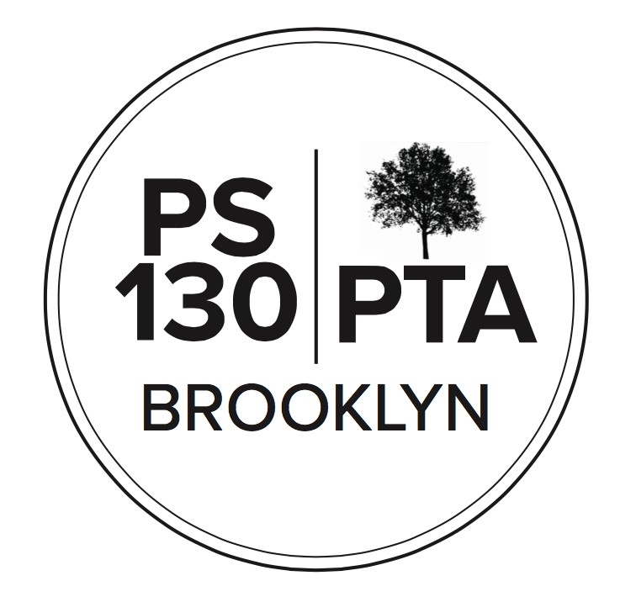
PS 130 PTA Meeting Agenda
April 18, 2023, 6:00 pm
Call to Order Reading of Minutes (Waived)
Principal’s Report (5 min) Stephanie Parsons: State tests ELA are tomorrow and Thursday. Math is May 2nd and 3rd. Admin has an ask for the PTA budget. Helen Lee, the Upper School secretary, passed away last fall. She was involved in the school as both a parent and a staff member. She was an important and integral part of our school. When Helen started, she began volunteering in the PreK classroom, which was the library room. The staff misses her and wants to honor her by creating a memorial space for her in the Lower School Library. Vote via poll to pay $1,100 for Helen Lee memorial space: passed

SP: In May every year we have a day for parent engagement. On one day in May, will have a science fair in the Upper School. Unlike Science Fairs of the past where there are individual student projects. this will be interactive projects made by Upper School students. Lower School grades will create an experience for families to take part in projects they've been doing. The Spring concert is May 10th.

Parent Coordinator Report (5 min) Jackie Hardy: We have 76% participation for school surveys. 209 families are missing. Making last final push. If you haven't submitted, please do so. Need to have OSIS number for your student(s). Your child's OSIS number is on your child's report card. If you need help, let Admin know.

Middle school offers are coming April 25th.

Bringing back Super Saturday: family event, collaborating with Arts Connection, there will be a Mexico Beyond Mariachi performance on April 29th.

Gretchen Nealon: Raising money for 5th grade BBQ. We'll get $2500 if we get enough volunteers for Brooklyn Half Marathon. Have 28 volunteers, need more.

Finances (10 min) (Regan Vidiksis)
1. Treasury report: Balance is $240,415. Income: $7710 for Annual Appeal, $2049 for Garden Committee for plant sale, $1346 for 5th grade bake sale, $1365 Yankee game ticket sale. Expenses: $2274 for Lice Prevention, $1800 for Spring Auction, $1331 or Plant Sales, $270 for instrument tuning.

New Business
- Nominating Committee - call for nominations: Looking for people to become leaders of the PTA next year. If you're interested in any of the positions to become an Exec Board, please contact the PTA. The PTA will have a parent social on May 5th where parents can hear more about the positions.
- Community Building (15 minutes)
  - Talent Show 4/28 - NEW TIME - Show starts at 6pm. Auditorium only holds so many people, trying to figure out the logistics. Need to reserve a ticket to come in. Will have Act 1 and Act 2, if you'd like to attend the whole show, need to reserve for both acts. Would the 5th grade like to do concessions? People have signed up to sell food and drinks. Can the show go until 9:30? SP: Admin will discuss.
  - Mexico Beyond Mariachi 4/29
  - Flea Market & Used Book Sale, Plus Plants! Sunday 4/30 1-4 pm, we will be taking donations 9-11 that morning. We need food donations for the 5th grade bake sale.
  - Family Fridays 5/5 (LS), 6/2 (US)
  - Donut Social for Caregivers - May 5th, 8:20-9:10am - Lower School Backyard
  - Yoga in the Yard 5/6, 5/13, 5/20
  - Spruce Up 5/7: Spring Garden Celebration this year, kids can show you what they planted, there will be garden crafts.
  - Teacher Appreciation Week May 8-12
  - Parkside Chat 5/9
  - Spring Concert 5/10
  - Spring Auction 5/13--we would love more parent community donations. In the past we've gotten artwork, services such as carpentry. If you have something that you make or do, please keep it in mind to donate. More details to come.
  - Science Fair - NEW DATE - 5/19, 3:30-7:30pm, Upper School
  - World Culture Day 5/21 US
  - Field Day 6/7 US, 6/16 LS: this is a fun day, will need lots of volunteers.
  - Have an idea for an event you want to coordinate? Please get in touch!
- Fundraising: (5 minutes)
- Committee Updates (3 minutes)
  - Afterschool (Tal Bar-Zemer): This is Trailblazers' last year at PS 130. Kids Orbit will expand to service both Upper and Lower School. Registration will start May 8th and will be rolling throughout the summer. Kids Orbit does great flexible programming and they do lots of enrichment: yoga, drama, etc. They have flexible packages for 3 days, etc. Financial aid is available.

Friends of PS 130: businesses who have donated services can get a sticker/window cling to post in their business.

Adjournment
Important Reminders
➢ April 21 - Eid, schools closed School resumes Monday, April. 24

Upcoming Events
- Apr. 17-20 - School Spirit Week - Earth Week
- Apr. 21 - Eid NO SCHOOL
- Apr. 24 - SLT meeting
- Apr. 27 - Equity and Inclusion Committee meeting

NEXT PTA MEETING - THURSDAY, MAY 18, 6:00 PM
Please “like” our PS 130 PTA Facebook page & follow us on Twitter + Instagram @ps130PTA Reach out: info@ps130pta.org

