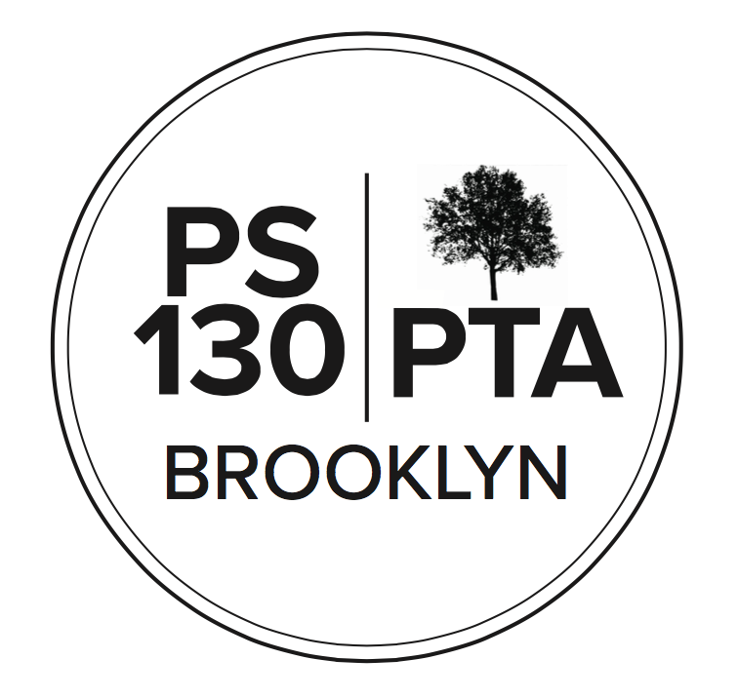

PS 130 PTA Meeting Agenda
June 15, 2023, 6:00 pm

Call to Order -

Reading of Minutes (Waived)

Principal’s Report (5 min) Field Day was yesterday and it went well. K graduation was today, was amazing. School budget meeting is tomorrow. The budget looks ok for now, probably no big changes from this year. No school on Monday. University Settlement’s last day was today. 5th grade graduation is next week, and 5th grade dance. Families will find out their new class placement toward the end of the summer.

Parent Coordinator Report (5 min) (no report)

Finances (10 min)
- Treasury report Assets are $241,629. Income: $30,768 from Spring Auction. $2200 from Brooklyn Cyclones, $6,950 from Yearbook Sales/Boosters. Expenses: $1,907 from Art Committee, $600 for instrument repairs, $7760 for SEL PD, $2,346 for Lice Prevention, $1,045 for Camera Club
- Proposed Budget SY2023-2024 – VOTE. Income: not a lot of changes from last year. Decreased Annual Appeal from $85k to $80k. Increasing Readathon income to $30k from $20k. Total income: expecting: $287,435. Expenses: Didn’t spend much for Artist Visits (authors, dance, etc.) this year. Put in $10k for next year. Put in $20k for Arts Connection. $20k proposed for Dancing Classrooms, an Enrichment program. Will have two teachers’ luncheons next year since the teachers didn’t get it this year. $2500 for Direct Outreach Honorarium – staff calls non-English-speaking families to help with anything they need. $5250 for Classroom calming supplies. Putting in $10k for Art Teacher Aide. Doubling custodial budget to $10k because need two new cafeteria tables. $4k for Classroom supplies.
- Budget passed.

New Business
- Election of new PTA Executive Board candidates – VOTE. Slate of candidates voted in: Kara Murray + Shaipe Dokovic as Co-Presidents, Mel Boller as Treasurer, Regan Vidiksis as Recording Secretary, Kathy Lando + Tal Bar-Zemer as Co-VP’s of Afterschool, Diana Rosenthal as VP of Community Affairs, Jonathan White + Dan Gordon as Co-VP’s of Events, Alizah Solario + Alison Bellevue as Co-Communications Secretaries, Laura Nemerson as VP of Fundraising.
- Community Building (15 minutes)
  - Field Day 6/14 (reschedule) US, 6/16 LS - sign up on Konstella
  - Grade picnics: End of year celebration on Saturday 6/24
  - Calendar planning for next year - meeting 6/21, 11am on zoom. All parents welcome.
- Fundraising: (5 minutes)
  - Year in review
  - CALL FOR VOLUNTEERS for Fall Fest - will meet over the summer to start planning: Last year’s committee was about 20 people, takes a lot of organization. Co-chairs are Laura Nemerson and Alison Bellevue.
- Committee Updates (3 minutes)
  - Afterschool: Afterschool Scholarship application is up and running.
  - ___________

Adjournment

Important Reminders
- June 19 - Juneteenth - SCHOOL CLOSED
- June 27 - LAST DAY OF SCHOOL - FULL DAY

Upcoming Events
- June 22 - Equity and Inclusion Committee meeting
- June 23 - End of Year Family Classroom Celebrations

Please “like” our PS 130 PTA Facebook page & follow us on Twitter + Instagram @ps130PTA
Reach out: info@ps130pta.org

