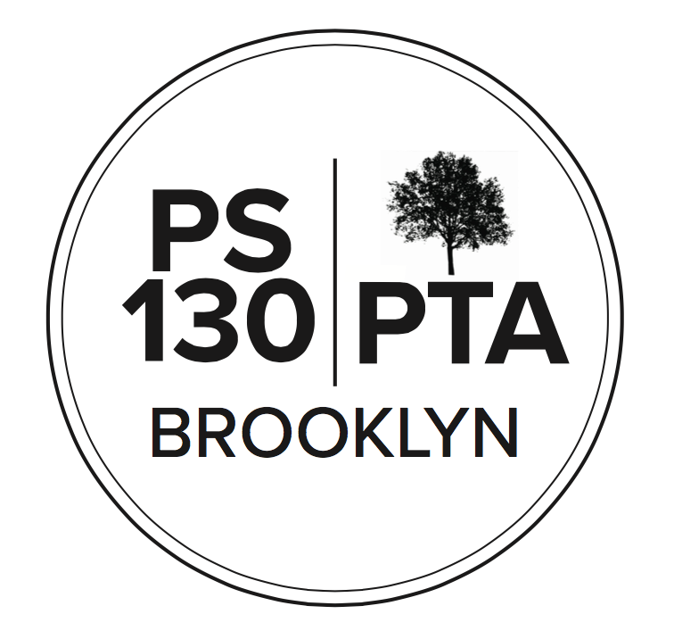

PS 130 PTA Meeting Agenda
May 18, 2023, 6:00 pm

Call to Order -

Reading of Minutes (waived)

Principal’s Report (5 min) (Meredith Jose) Field Day is coming up. Upper School June 7th, Lower School June 16th. Volunteers needed. Next week is 5th grade Broadway show trip. Lots of field trips coming up. STEAM fair and art fair last week was amazing!

Parent Coordinator Report (5 min) (Jackie Hardy) It’s crunch time for staff. There’s a lot going on, having a lot of events in a short amount of time. PreK offers went out today. Field day: flyer will go home next week. University Settlement cancelled on May 25th. Shoutout to Yearbook Committee: crunch time for them, all the pieces are going in. They're working hard behind the scenes.

Finances (10 min)
- Treasury report (Regan Vidiksis): $227,998 in account. Income: Flea Market/Book sale brought in $3,194. $400 from Brooklyn Cyclones game, $1,446 for Annual Appeal, $1,185 for Rainbow Club T-shirts, Yearbook booster ads: $5,120. Expenses: $12,350 for Sex Ed workshops, $5850 for Social Emotional Learning, $2,747 for Teacher and Staff Discretionary, $305 for Chess Scholarships,
- Proposed Budget Amendments - VOTE
  - Teacher Appreciation - increase from $1500 to $3100: end-of-year teacher luncheon
  - Community Events - increase from $5600 to $7600: End-of-year celebrations are historically class-dependent. Could we gather each grade at a specific time on weekend in the park and have the PTA support with snacks, water, a fun activity or two. Leave the rest up to classes. Lay the framework.
  - Both passed

New Business
- Nominating Committee: Nominations closed [list all], Laura Nemerson stepped up for Fundraising
- Budget Committee: putting a plan of action together, reaching out to committee chairs. One parent idea: do a T-shirt for every kid in the school. If anyone has any questions, let us know. The goal is to get more ideas from the community. Also reaching out to teachers and Admin to see if they have any enrichment plans and projects. Need more people to help us spend the money next year. Even if the idea isn't fully fleshed out, ok to share. Contact ps130budget@gmail.com.
- Community Building (15 minutes)
  - Yoga 5/20 email instructor by Fri @ 5 to sign up, elyce@elycesemenecwellness.com
  - Center for Arts Day 5/21 (PreK-2 - signups went out)
  - World Culture Day 5/21 US - volunteers needed: (Deshant Paul): it will be a beautiful Sunday; part of 2nd grade class will perform with Ms. Sorenson. We need volunteers! We have a few positions open, you can switch off positions if you'd like. It's a lot of fun. We need people to help serve food. Need help with breakdown. The day after is a school day so we want to make sure we return the school the way we found it. If you're planning on bringing a dish, please sign up on Konstella.
  - Field Day 6/7 US, 6/16 LS - sign up on Konstella
  - Grade picnics, date TBD.
  - Have an idea for an event you want to coordinate? Please get in touch!
- Fundraising: (5 minutes) Megan: the auction was very fun, great to see people in real life! Thanks to all the folks who worked to put on a cool event. Shout-out to the Auction Committee. (Liz): thanks to everyone for the auction, we netted around $32k. It was a super successful event. If you won a prize and haven't been contacted by the auction committee, contact: ps130auction@gmail.com
  - NYCFC -- deadline is May 24th, game is June 3rd. Cyclones -- deadline of May 26th, game on June 11th. Mets game on June 18th.
- Committee Updates (3 minutes)
  - Afterschool: Last week sent out Afterschool needs survey. Survey helps us figure out who has a need for scholarships. Cannot start working on who gets scholarships unless we know who needs them. Still plenty of room in Kids Orbit. Trying to update PTA website with registration dates for pickup programs. Shana Williams: It would be easier to have a quick flyer about things like Don't forget to fill out your Afterschool form. Kathy: will do, with QR code.

Adjournment

Important Reminders
- May 29 - Memorial Day - SCHOOL CLOSED
- June 8 & June 9 - Chancellor’s Day; Clerical Day - SCHOOL CLOSED

Upcoming Events
- May 22 - SLT meeting
- May 25 - Equity and Inclusion Committee meeting
- June 12 - SLT meeting

NEXT PTA MEETING - THURSDAY, JUNE 15, 6:00 PM
Please “like” our PS 130 PTA Facebook page & follow us on Twitter + Instagram @ps130PTA
Reach out: info@ps130pta.org

